WEEK 1 PORTFOLIO SITEMAP
GENERAL AI FLUENCY • TRACK SUBMISSION
NAME | John Patrick Ilagan
PRIMARY TRACK | Backend AI Engineering
SUBMISSION TRACK | General AI Fluency
QUICK PROJECT CONTEXT
This portfolio is designed to prove one repeatable outcome: Patrick can turn a defined product idea into a working AI-powered MVP. The intended reader is the technical founder of an early-stage AI SaaS startup, and the single action is to hire Patrick as a paid AI development intern.
VISUAL DIRECTION
One polished scrolling website with one persistent abstract AI environment—not a separate 3D scene for every project. The background may use flowing particles, interconnected lines, data-like motion, depth, and subtle cursor interaction. Project names, short descriptions, screenshots, and proof links reveal quickly over the same environment. The style should feel minimal, cinematic, dark, and green-led, with original visuals inspired by spatial interactive websites and minimalist sci-fi games rather than copied from them.

PROOF STATEMENT USED FOR THIS BUILD
CLAIM + PERSON + ACTION
I am proving one primary skill: AI product prototyping—the ability to turn a defined product idea into a deployed, working AI-powered MVP using AI-assisted development. I am proving this to the technical founder of an early-stage AI SaaS startup who is hiring a junior builder to rapidly prototype new product experiences. My portfolio will prove this through working AI products across learning, finance, travel, mood tracking, and interface design. The single action I want that founder to take is to hire me as a paid AI development intern.

PORTFOLIO SITEMAP
SMALL STRUCTURE • EVERY PART EARNS ITS PLACE
Core sitemap: one scrolling homepage plus one optional reusable project proof view.
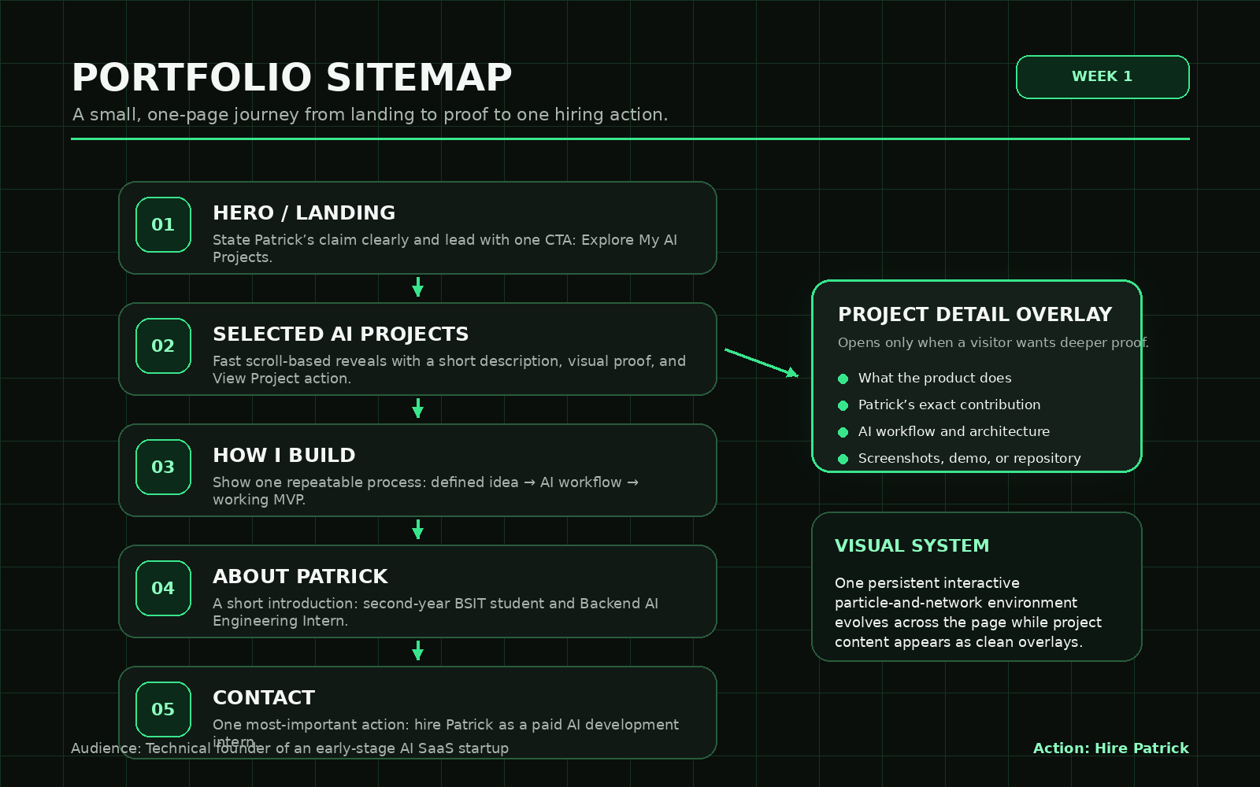
The homepage is the main experience. A project proof view opens only when a visitor wants deeper evidence; it uses the same layout for every project and does not create unnecessary pages.

VISITOR FLOW
FROM LANDING TO BELIEVING TO ONE ACTION
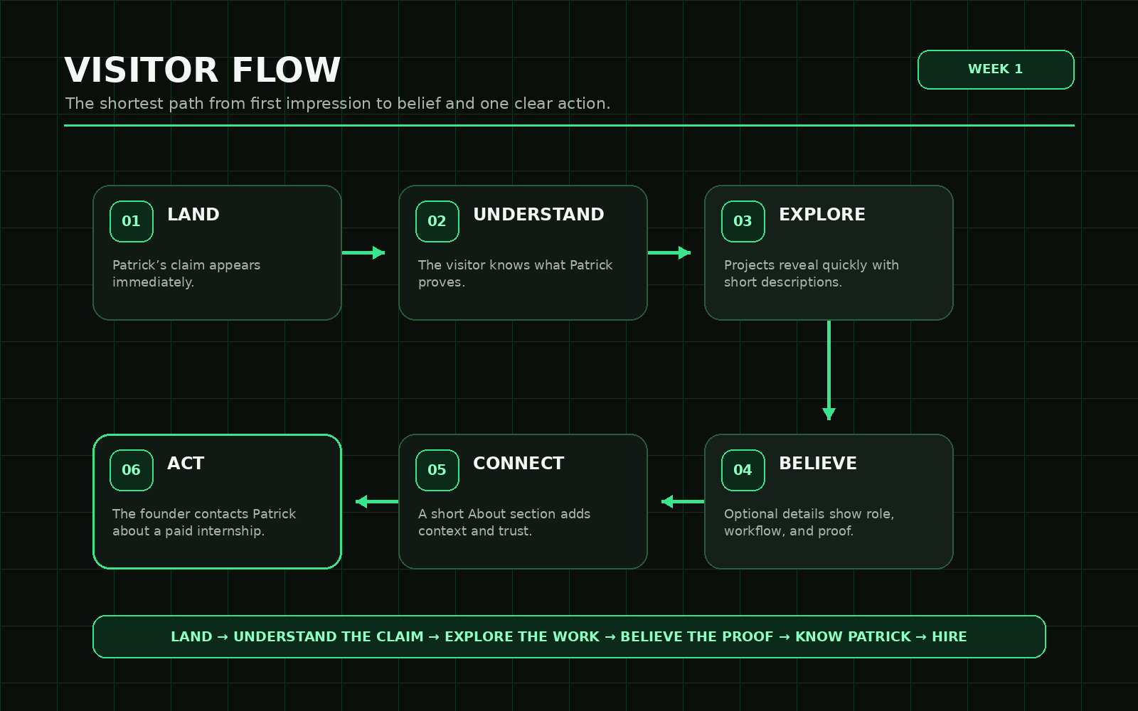
WHY THE SECTIONS STAY
Hero | States the claim immediately and gives the visitor a clear entry point.
Selected AI Work | Provides the strongest evidence through several fast project reveals rather than one oversized flagship section.
How I Prototype | Shows that the results come from a repeatable process, not accidental one-off demos.
About Patrick | Adds only the context needed to understand his current level, role, and honest AI-assisted working style.
Contact | Asks for one action: discuss a paid AI development internship.

SELECTED WORK CONTENT
SHORT REVEALS ON THE HOMEPAGE
Each project should appear quickly: project name, one-sentence outcome, one visual, and one proof link. The same interactive background remains active throughout.
PRISMLEARNING.AI
Turns uploaded lessons into personalized AI tutoring experiences through explanations, examples, questions, and learning assessments.

FINGENT.AI
A contextual AI assistant designed around safer, more useful financial tracking experiences.

TOURISMBUDDY
Generates itinerary guidance from a traveller’s preferences and trip context.

MOODIE
Uses mood-tracking context to provide more relevant, personalized suggestions.

NATIVBUILD / UPCOMING WORK
An upcoming AI product for generating interface designs; public details remain limited until Patrick is ready to reveal them.

REUSABLE PROJECT PROOF VIEW
When someone clicks a project, show only the evidence needed to judge the same claim: the product outcome, what the AI does, Patrick’s exact contribution, the workflow or architecture, a live demo or screenshots, and one honest improvement still needed.

CLAUDE PROJECT SETUP
COPY-READY CONTENT FOR THE REQUIRED SCREENSHOT
PROJECT NAME
NAME
Patrick — AI Product Portfolio

CUSTOM INSTRUCTIONS
Act as my tutor and critical thinking partner for this ten-week portfolio build. Do not simply agree with me or write the whole project for me. Ask sharp questions, explain trade-offs, challenge vague claims, and point out any page, section, animation, or project that does not strengthen my proof or move the intended reader toward the one action.
My proof statement:
I am proving one primary skill: AI product prototyping—the ability to turn a defined product idea into a deployed, working AI-powered MVP using AI-assisted development. I am proving this to the technical founder of an early-stage AI SaaS startup who is hiring a junior builder to rapidly prototype new product experiences. My portfolio will prove this through working AI products across learning, finance, travel, mood tracking, and interface design. The single action I want that founder to take is to hire me as a paid AI development intern.
My portfolio concept:
A small, polished portfolio with one scrolling homepage and one optional reusable project proof view. The homepage uses one persistent abstract AI environment with flowing particles, interconnected systems, subtle cursor interaction, and scroll-driven motion. Projects reveal quickly through short descriptions and proof links over the same environment.
Judge every recommendation against three questions:
1. Does it strengthen my claim that I can prototype working AI products?
2. Does it help a technical founder of an early-stage AI SaaS startup believe that claim?
3. Does it move that founder toward hiring me as a paid AI development intern?
Teach me rather than replacing my thinking. Push back when I add unnecessary pages, decorative effects with no purpose, or claims I cannot honestly prove.

FIRST PRESSURE-TEST PROMPT
RUN THIS IN THE CONFIGURED CLAUDE PROJECT AND SAVE THE OUTPUT
You are my tutor and critical thinking partner for this ten-week portfolio build. Your role is to help me make strong decisions, understand my own work, and improve the portfolio, not to take over the project or automatically agree with me.

My name is Patrick. I am a second-year BSIT student and a Backend AI Engineering Intern. I am working toward becoming a Full-Stack AI Developer or Engineer. I use AI-assisted development to help plan workflows, explore architecture, generate implementation, troubleshoot problems, and turn product ideas into working prototypes. Keep my positioning honest. Do not describe me as an independent expert engineer when the evidence does not support that.

My proof statement is:

I am proving one primary skill: AI product prototyping, the ability to turn a defined product idea into a deployed, working AI-powered MVP using AI-assisted development. I am proving this to the technical founder of an early-stage AI SaaS startup who is hiring a junior builder to rapidly prototype new product experiences. My selected AI projects provide evidence that I can apply this ability across different use cases. The single action I want that founder to take is to contact me to discuss hiring me as a paid AI development intern.

Why the portfolio needs to exist:

A CV or LinkedIn can list my technologies and projects, but it cannot prove that I can take an AI product idea from workflow design to a functioning, deployed experience.

My approved portfolio sitemap is:

Hero: States my claim immediately and provides a clear entry point.

Selected AI Work: Presents several fast project reveals as evidence of repeated AI product prototyping.

How I Prototype: Explains my repeatable process for turning a defined idea into a working AI-powered MVP.

About Patrick: Provides only the context needed to understand my current level, role, and honest AI-assisted working style.

Contact: Asks for one action, which is to contact me to discuss a paid AI development internship.

Judge every recommendation against these three questions:

Does this strengthen my claim that I can prototype working AI products?

Does this help a technical founder of an early-stage AI SaaS startup believe that claim?

Does this move that founder toward contacting me about a paid AI development internship?

Act as a tutor who explains the reasoning behind recommendations. Ask sharp questions when important information is missing. Push back when I am vague, exaggerating, adding unnecessary sections, or trying to prove several unrelated skills. Help me compare options and make the final decisions myself. Point out weaknesses honestly and distinguish between what my portfolio currently proves and what I still need to demonstrate.

Message to send with the document:

I have attached my portfolio context document. It contains my final proof statement, the reason the portfolio needs to exist, my approved portfolio sitemap, the purpose of each section, and the intended visitor flow. Use this document as the source of truth for this ten-week build. Please act as my tutor, explain the reasoning behind your advice, challenge weak or unnecessary choices, and judge every recommendation against my claim, target audience, and desired hiring action.

DRAFT CHANGE NOTE
UPDATE THIS AFTER READING THE REAL OUTPUT
After pressure-testing the sitemap, I will keep the portfolio as one main scrolling page with one reusable project proof view. I will also use one persistent interactive AI environment instead of creating a different 3D background for every project, so the visuals support the proof without making the site slower or harder to understand.

TOOLKIT AND STARTING CONTEXT
ONLY THE MATERIAL NEEDED TO BEGIN NEXT WEEK
FREE TOOLKIT
Create or confirm accounts for Claude, ChatGPT, Gemini, and Perplexity. The required Claude Project is named “Patrick — AI Product Portfolio” and uses the custom instructions in this document.
PROPOSED TECHNICAL STACK
- React + TypeScript + Vite for the portfolio application.
- React Three Fiber + Drei for the persistent particle/network environment and pointer interaction.
- GSAP ScrollTrigger for scroll-linked camera, text, and project-reveal sequences.
- Standard HTML/CSS UI layers for readable project content over the 3D canvas.
- Vercel for deployment, with a reduced-motion and lightweight mobile fallback.
OPTIONAL STARTING BUILD PROMPT
Create the first functional version of Patrick’s one-page AI product portfolio. Use React, TypeScript, and Vite. Build five accessible sections: Hero, Selected AI Work, How I Prototype, About Patrick, and Contact. Add one fixed full-screen React Three Fiber canvas behind the content with a restrained emerald particle-and-network system that reacts subtly to cursor movement. Use scroll progress to evolve the same environment across sections instead of replacing it with separate scenes. Use GSAP ScrollTrigger for controlled section reveals. Keep project content data-driven, readable, keyboard accessible, and easy to replace. Include reduced-motion support and a simple mobile fallback. Prioritize structure, clarity, and performance before advanced visual polish.

Technical reference choices were checked against the current official documentation for Vite, React Three Fiber, and GSAP ScrollTrigger.

